**The Battle of Neighborhoods - Coursera Capstone Project**

A JOURNEY INTO THE RESTAURANTS OF TORONTO

# Introduction

* The goal of this project is to give a recommendation to tourists in Toronto regarding the district of the city in which they could find the higher concentration of specific kinds of restaurants. The target audience of the project are indeed foreign tourists looking for a culinary experience in the city of Toronto.
* After a brief analysis of the venues in Toronto, the work will focus on the restaurants distribution over the territory; in particular, we will classify the neighborhood by clustering them according to the type of restaurants mostly represented in the neighborhood itself.
* Finally, the analysis will focus on the possibility of finding vegetarian restaurants in the city of Toronto.

# Data

* We will leverage Foursquare location data and machine learning to address the problem, in particular, Foursquare location data and clustering methods will allow to group the neighbourhoods according to their restaurant venues information.
* In detail, the data will be collected via several CVS file from difference data sources:
  + via Wikipedia, we will collect the list of neighbourhoods in Toronto (
  + via Geocoder package, we will address the Geographical location of the neighbourhoods
  + via Forursquare we will collect the Venue data, and in particular the restaurants in Toronto.

## Data acquisition

1. **Toronto Neighborhoods**: <https://en.wikipedia.org/wiki/List_of_postal_codes_of_Canada:_M> , the Wiki page of Toronto Neighborhood provided all the information about the postal code, borough and the name of the neighbourhoods of Toronto.

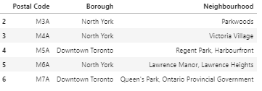

1. **Geographical location**: <https://cocl.us/Geospatial_data> , using the Geocoder Package we obtained the geographical coordinates of the different neighborhoods in Toronto.

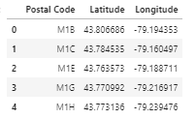

### **Venues data:** venues data, and in particolar restaurant ones, have been obtained by Foursquare.

